عبد العزيز مطيع الفهد

# تكليف المحضره الثالثه

using System;  
using System.Collections.Generic;  
using System.ComponentModel;  
using System.Data;  
using System.Drawing;  
using System.Linq;  
using System.Text;  
using System.Threading.Tasks;  
using System.Windows.Forms;  
  
namespace WindowsFormsApp11  
{  
    public partial class Form1 : Form  
    {  
        public Form1()  
        {  
            InitializeComponent();  
            textBox2.Focus();  
        }  
  
        private void Form1_Load(object sender, EventArgs e)  
        {  
              
            MessageBox.Show("انقر على الواجهة للحصول على الوان مختلفة", "ترحيب ", MessageBoxButtons.OKCancel);  
            this.CenterToParent();  
            textBox1.Text = "عبد العزيز الفهد" + "\r\n";  
        }  
  
        private void Form1_MouseClick(object sender, MouseEventArgs e)  
        {  
            Random r = new Random();  
            this.BackColor = Color.FromArgb(r.Next(0, 255), r.Next(0, 255),  
            r.Next(0, 255));  
  
        }  
  
        private void textBox2_TextChanged(object sender, EventArgs e)  
        {  
            if (textBox1.Text.Trim() != "")  
                textBox1.BackColor = Color.Yellow;  
            else  
                textBox1.BackColor = Color.White;  
  
        }  
  
        private void button2_MouseEnter(object sender, EventArgs e)  
        {  
            textBox1.ForeColor = Color.Red;  
            textBox1.BackColor = Color.Yellow;  
        }  
  
        private void button1_MouseLeave(object sender, EventArgs e)  
        {  
            textBox1.ForeColor = Color.Red;  
            textBox1.BackColor = Color.Yellow;  
        }  
  
        private void Form1_FormClosing(object sender, FormClosingEventArgs e)  
        {  
            MessageBox.Show("معسلامه");  
        }  
  
        private void button2_Click(object sender, EventArgs e)  
        {  
            this.Close();  
        }  
        private bool isnumber(string s)  
        {  
            for (int i = 0; i < s.Length; i++)  
                if (s[i] >= 48 && s[i] <= 57)  
                    return true;  
            return false;  
        }  
        int x = 0;  
  
        private void button1_Click(object sender, EventArgs e)  
        {  
            if(textBox1.Text.Trim()!="" && !isnumber(textBox1.Text))  
            {  
                textBox1.Text += textBox2.Text + "\r\n".ToString();  
                textBox2.Focus();  
                textBox2.Clear();  
            }  
            else  
            {  
                MessageBox.Show("خطا في مربع النص ");  
                textBox1.Focus();  
                textBox1.Clear();  
  
            }  
        }  
  
        private void button1_MouseHover(object sender, EventArgs e)  
        {  
            button1.BackColor = Color.Black;  
        }  
    }  
    }

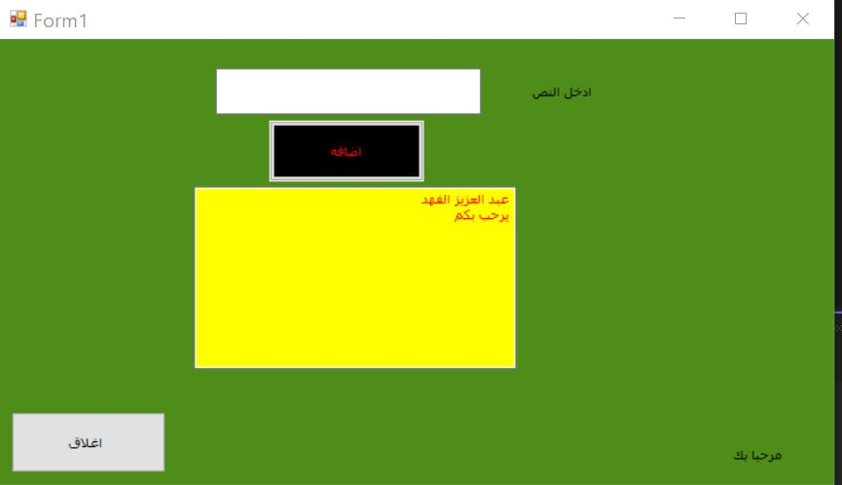

using System;  
using System.Collections.Generic;  
using System.ComponentModel;  
using System.Data;  
using System.Drawing;  
using System.Linq;  
using System.Text;  
using System.Threading.Tasks;  
using System.Windows.Forms;  
  
namespace WindowsFormsApp17  
{  
    public partial class Form1 : Form  
    {  
        string[] a;  
        int m = 0, i = 0;  
        public Form1()  
        {  
            InitializeComponent();  
        }  
  
        private void Form1_Load(object sender, EventArgs e)  
        {  
            Random r = new Random();  
            this.BackColor = Color.FromArgb(r.Next(0, 255), r.Next(0, 255), r.Next(0, 255));  
           txtadd.Enabled = textBox3.Enabled = button1.Enabled = button4.Enabled = button3.Enabled = listBox1.Enabled = false;  
        }  
  
        private void button3_Click(object sender, EventArgs e)  
        {  
            listBox1.Items.Clear();  
            if (i > 0)  
            {  
                for (int h = 0; h < i; h++)  
                {  
                    listBox1.Items.Add(a[h]);  
                }  
            }  
            else  
                MessageBox.Show("المصفوفه فارغه");  
        }  
  
        private void button4_Click(object sender, EventArgs e)  
        {  
            int s = 0;  
            if (listBox1.Items.Count > 0)  
            {  
                for (int h = 0; h < i; h++)  
                {  
                    s += int.Parse(a[h]);  
                }  
                textBox3.Text = s.ToString();  
            }  
            else  
                MessageBox.Show("القائمه فارغه");  
  
        }  
  
        private void textBox1_TextChanged(object sender, EventArgs e)  
        {  
            bool f = (textBox1.Text != "");  
            txtadd.Enabled = textBox3.Enabled = button1.Enabled = button4.Enabled = button3.Enabled = listBox1.Enabled = f;  
            listBox1.Items.Clear();  
        }  
  
          
  
          
  
        private void textBox1_MouseLeave(object sender, EventArgs e)  
        {  
            if (textBox1.Text.Trim() != "")  
            {  
                m = int.Parse(textBox1.Text);  
                a = new string[m]; i = 0;  
            }  
              
        }  
  
        private void txtadd_KeyPress(object sender, KeyPressEventArgs e)  
        {  
            if(e.KeyChar<48||e.KeyChar>57)  
            {  
                e.Handled = true;  
            }  
            if (e.KeyChar == 8)  
                e.Handled = false;  
  
        }

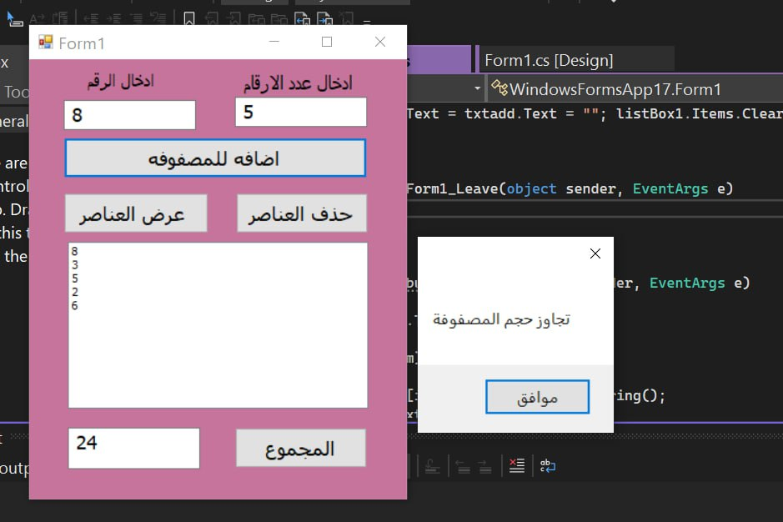private void button2_Click(object sender, EventArgs e)  
        {  
            textBox3.Text = txtadd.Text = ""; listBox1.Items.Clear();  
  
        }  
  
        private void Form1_Leave(object sender, EventArgs e)  
        {  
  
        }  
  
        private void button1_Click(object sender, EventArgs e)  
        {  
            if(txtadd.Text.Trim()!="")  
            {  
                if(i<m)  
                {  
                    a[i++] = txtadd.Text.ToString();  
                    txtadd.Focus();  
                    txtadd.Clear();  
                }  
                else  
                {  
                    MessageBox.Show("تجاوز حجم المصفوفة");  
                }  
            }  
            else  
            {  
                MessageBox.Show("اتخل الرقم");  
            }  
        }  
    }  
}

using System;  
using System.Collections.Generic;  
using System.ComponentModel;  
using System.Data;  
using System.Drawing;  
using System.Linq;  
using System.Text;  
using System.Threading.Tasks;  
using System.Windows.Forms;  
  
namespace WindowsFormsApp18  
{  
      
    public partial class Form1 : Form  
    {  
        int x=5;  
        public Form1()  
        {  
            InitializeComponent();  
        }  
  
        private void b_Click(object sender, EventArgs e)  
        {  
            button1.Top += x;  
        }  
  
        private void up_Click(object sender, EventArgs e)  
        {  
            button1.Top -= x;  
        }  
  
        private void lft_Click(object sender, EventArgs e)  
        {  
            button1.Left += x;  
        }  
  
        private void rit_Click(object sender, EventArgs e)  
        {  
            button1.Left -= x;  
        }  
  
        private void plslft_Click(object sender, EventArgs e)  
        {  
            button1.Size = new Size(button1.Width+=x, button1.Height );  
        }  
  
        private void minsrit_Click(object sender, EventArgs e)  
        {  
            button1.Size = new Size(button1.Width -= x, button1.Height);  
        }  
  
        private void minsb_Click(object sender, EventArgs e)  
        {  
            button1.Size = new Size(button1.Width , button1.Height-= x);  
        }  
  
        private void blsup_Click(object sender, EventArgs e)  
        {  
            button1.Size = new Size(button1.Width, button1.Height += x);  
        }  
  
  
  
        private void button2_Click(object sender, EventArgs e)  
        {  
            if (radioButton1.Checked)  
            {  
                for (int i = 0; i < Top; i++)  
                {  
                    if (checkBox1.Checked)  
                    {  
                        button1.Top -= Convert.ToInt32(checkBox1.Text);  
                    }  
                    else if (checkBox2.Checked)  
                    {  
                        button1.Top -= Convert.ToInt32(checkBox2.Text);  
                    }  
                    else if (checkBox3.Checked)  
                    {  
                        button1.Top -= Convert.ToInt32(checkBox3.Text);  
                    }  
                    else if (checkBox4.Checked)  
                    {  
                        button1.Top -= Convert.ToInt32(checkBox4.Text);  
                    }  
                    for (int j = 0; j < 1000000000; j++) ;  
                }  
            }  
            else if (radioButton2.Checked)  
            {  
                for (int i = 0; i < Top; i++)  
                {  
                    if (checkBox1.Checked)  
                    {  
                        button1.Top += Convert.ToInt32(checkBox1.Text);  
                    }  
                    else if (checkBox2.Checked)  
                    {  
                        button1.Top += Convert.ToInt32(checkBox2.Text);  
                    }  
                    else if (checkBox3.Checked)  
                    {  
                        button1.Top += Convert.ToInt32(checkBox3.Text);  
                    }  
                    else if (checkBox4.Checked)  
                    {  
                        button1.Top += Convert.ToInt32(checkBox4.Text);  
                    }  
                    for (int j = 0; j < 1000000000; j++) ;  
                }  
            }  
        }  
        private void button3_Click(object sender, EventArgs e)  
        {  
            for (int j = 0; j < 20; j++)  
            {  
  
                for (int i = 0; i < 200; i++)  
                {  
                    button2.Left += 2;  
                }  
                for (int i = 0; i < 200; i++)  
                {  
                    button2.Left -= 2;  
                }  
            }  
        }  
    }  
}

